Goldspink, Dallas
Plantations forestry - a growth industry of opportunity
Article Date:01/04/2009 from Getfarming Australia website
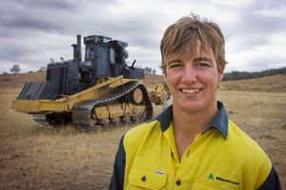
Dallas Goldspink, 19, is the latest in a long line of family Foresters to achieve a job in the plantation industry.
Tumbarumba has talent. Dallas Goldspink, 19, is the latest in a long line of family Foresters to achieve a job in the plantation industry.
Dallas Goldspink has been interviewed as part of a 2009 national program designed to highlight the benefits of plantation forestry jobs for an industry and government organisation, Plantations for Australia: The 2020 vision.
Dallas has a brand new career ahead of him after securing a job with Willmott Forests Limited at Tumbarumba.
He approached the friendly team at the plantation and processing company, asked for a job and got exactly that - an exciting career to carry on the tradition of his grandfathers, father and sister before him.
In year nine of high school, Dallas worked as part of a pine planting crew and his interest in the science of forestry began.
"I started at Willmott Forests over the summer and have deferred my place at The Australian National University for a year.
I start at university in February for four years of study and practical experience and from there I'll get a job in the industry," says Dallas.
He completed the BSc Forestry ANU degree in 2012, graduated 2013.

